**FRESH MORNING**

The mystifying spectrum of Eos' robes;  
Where the aureate Phoebus reinforces its vigour,  
Thriving avidly amidst the argent nephos,  
Stealing over the slackening darkling dour.  
  
The vault of azure unfurls across Ceres' meadows,  
To count for the overnight showers;  
And petite droplets cling onto the leaves,  
Astride the dazzling, riparian borders.  
  
The astute aria of the passerines' tones,  
Connate clepsydras of the earth.  
And the world arises to their ardent summons  
To commence an eve with diligence and mirth;  
To reunite with their praxis and itinerant chores:  
An occasion of hope, aspirations and desires.  
     
                                                                -Aadityaamlan Panda

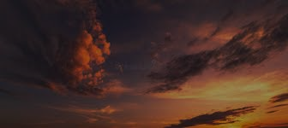

**FRESH MORNING**

The mystifying spectrum of Eos' robes;  
Where the aureate Phoebus reinforces its vigour,  
Thriving avidly amidst the argent nephos,  
Stealing over the slackening darkling dour.  
  
The vault of azure unfurls across Ceres' meadows,  
To count for the overnight showers;  
And petite droplets cling onto the leaves,  
Astride the dazzling, riparian borders.  
  
The astute aria of the passerines' tones,  
Connate clepsydras of the earth.  
And the world arises to their ardent summons  
To commence an eve with diligence and mirth;  
To reunite with their praxis and itinerant chores:  
An occasion of hope, aspirations and desires.  
     
                                                                -Aadityaamlan Panda